**2019 Events Calendar**

***(All Seminar Times: 10:00 am to 11:30 am)***

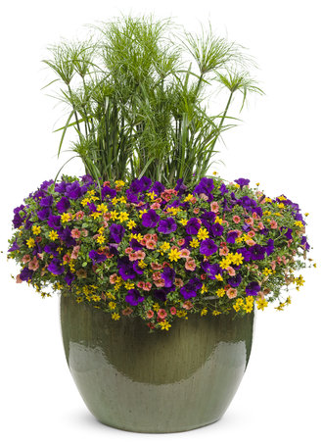**January/February:**

* Bring your containers for planting M thru F, 9 am to 5 pm:
  + Before March 11
    - $2.50/inch (rectangular flower box length)
    - $3.00/inch (planter diameter)
  + After March 11
    - $3.00/inch (rectangular flower box length)
    - $3.50/inch (planter diameter)

**March:**

* 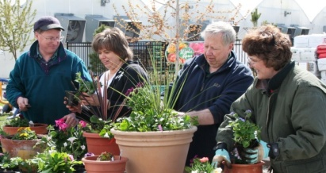Event: March 04, Season Opening
* Seminar: March 09, Pruning for Success (*Free*)
* Seminar: March 16, Pruning for Success (*Free*)
* Seminar: March 30, Spring Garden Prep *(Free*)

**April:**

* Seminar: April 06, Fairy/Mini Gardens (*$30 for class materials*)
* Seminar: April 13, Airarrium Creation w/Tillandesias
* 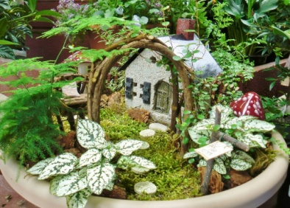Seminar: April 20, Bonsai for Beginners (*$30 for class materials*)
* Event: April 26 & 27, Pot Party (*You buy the plants, we provide the soil*)

**May:**

* Seminar: May 04, Fairy/Mini Gardens (*$30 for class materials*)
* Event: May 10 & 11, Mother’s Day Basket Bonanza
* Seminar: May 18, Pondscapes
* Seminar: May 25, Intermediate Bonsai (*$30 for class materials*)

**June:**

* Seminar: June 01, Fairy/Mini Gardens (*$30 for class materials*)
* Event: June 03 through 08, Kidz Dayz (*$5/child*)
* Seminar: June 15, Herbs (*Free*)
* Seminar: June 22, Veggies (*Free*)
* Seminar: June 29, Bonsai for Beginners (*$30 for class materials*)

**July:**

* Event: All Month, Red, White and Blue Days (*10, 20, 30 Percent Discounts*)
* Seminar: July 06, Fairy/Mini Gardens (*$30 for class materials)*
* Seminar: July 20, Kidz Day Make a Garden Tic-Tac-Toe ($5/Child)
* Seminar: July 27, Intermediate Bonsai (*$30 for class materials*)

**August:**

* Event: All Month, Close-out Sales Begin
* Seminar: August 03, Fall Garden Prep (*Free*)

**September:**

* Event: All Month, Plant for Fall & Spring! Fall Mums & Spring Bulbs Available!
* Event: All Month, Close-out Sales