Working With Your Fresh Vegetables & Fruit
By
Chef Mark Standefer
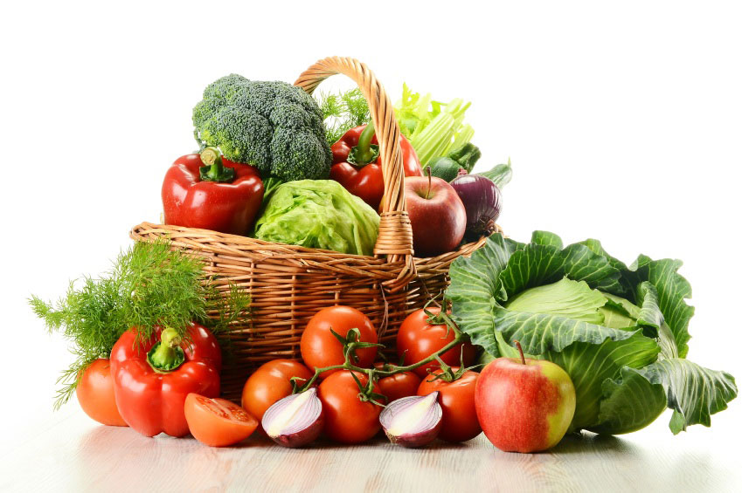

McCoard’s Garden Center
384 S. 3110 W.
Provo, UT 84601

Email: info@mccoards.com
Visit our website at www.mccoards.com
801-373-1262

2017

Notes:
______________________________________________________________________________________________________________________________________________________________________________________________________________________________________________________________________________________________________________________________________________________
______________________________________________________________________________________________________________________________________________________________________________________________________________________________________________________________________________________________________________________________________________________
______________________________________________________________________________________________________________________________________________________________________________________________________________________________________________________________________________________________________________________________________________________
______________________________________________________________________________________________________________________________________________________________________________________________________________________________________________________________________________________________________________________________________________________
_____________________________________________________________________________________________________________________________________________________________________________________________________________________________________________________________________________________________
Notes:
______________________________________________________________________________________________________________________________________________________________________________________________________________________________________________________________________________________________________________________________________________________
______________________________________________________________________________________________________________________________________________________________________________________________________________________________________________________________________________________________________________________________________________________
______________________________________________________________________________________________________________________________________________________________________________________________________________________________________________________________________________________________________________________________________________________
______________________________________________________________________________________________________________________________________________________________________________________________________________________________________________________________________________________________________________________________________________________
_____________________________________________________________________________________________________________________________________________________________________________________________________________________________________________________________________________________________
Veggie Kabobs with Herb and Garlic Marinade
Ingredients
- 1 cup eggplant chunks
- 1 cup red, yellow or green bell pepper chunks
- 1 cup fresh pineapple chunks
- 1 cup red onion chunks
- 1 cup white button mushrooms
- 1 cup zucchini or yellow squash chunks
- 1 cup cherry tomatoes
- Marinade (recipe follows)
- Wooden skewers, soaked in water for 30 minutes
Directions
Place the vegetables in a shallow dish or container. Pour marinade over vegetables. Cover and refrigerate for 2 hours.

Preheat an outdoor grill to medium heat.

Remove vegetables from the marinade, reserving marinade. Thread vegetable onto skewers, alternating colors. Cook skewers on grill until vegetables are lightly charred all over, about 10 minutes, basting with reserved marinade and turning occasionally.

Marinade
- ½ cup olive oil or herb oil
- 1 tablespoon lemon or lime juice
- 2 tablespoons minced garlic
- 2 tablespoons chopped fresh basil leaves
- ½ tsp. salt
- ½ tsp. black pepper

Whisk together all ingredients in a small bowl. The marinade can be prepared in advance or held covered in the refrigerator for up to 7 days.

1
Tomato Kabobs
Ingredients
- 3 tablespoons good olive oil or herb oil
- 2 pints cherry tomatoes
- ½ red onion, julienne
- Wooden skewers, soaked in water for 30 minutes
- ¼ tsp. salt
- ¼ tsp. black pepper

Directions
Heat grill to medium-high. Season the grill with oil.

Toss the tomatoes and onions with olive oil and sprinkle with salt and pepper. Loosely thread 4 or 5 cherry tomatoes and red onions onto skewers, threading them through the stem of the tomato.

Place the tomato skewers on the grill and cook for approximately 5 minutes, turning each minute.

2
Roasted Brussels Sprouts
Ingredients
- 1 ½ pounds Brussels sprouts, trimmed
- 3 tablespoons olive oil or herb oil
- 1 tsp. Kosher salt
- ½ tsp. black pepper

Directions
- Preheat oven to 400 degrees.
- Place Brussels sprouts, oil, salt and pepper in a large re-sealable plastic bag.
- Seal tightly and shake to coat.
- Pour onto a baking sheet and place on center oven rack.
- Roast in the preheated oven for 30-45 minutes.
- Shake pan every 5-7 minutes for even browning.
- Reduce heat when necessary to prevent burning.
- Brussels sprouts should be a dark brown, almost black when done.
- Adjust seasoning with salt and pepper if necessary.
- Serve immediately.

15
Chocolate Zucchini Cake

Ingredients
- 1 stick margarine (softened)
- 2 ½ cup flour
- ½ cup oil
- ½ tsp. salt
- 1 ¾ cup sugar
- 1 tsp. baking soda
- 2 eggs
- ½ tsp. cinnamon
- 1 tsp. vanilla
- 4 tablespoons cocoa
- ½ cup buttermilk (or ½ cup milk with 1 tsp. vinegar)
- 2 cup raw grated zucchini
- ½ cup chocolate chips
- ½ cup nuts

Directions
Cream sugar, oil and margarine. Add eggs and vanilla.
Beat well and add milk. Sift dry ingredients and blend into
creamed mixture. Stir in zucchini and pour into greased and floured 9” x 13” pan. Sprinkle on chocolate chips and nuts. Bake at 325° for 45 minutes.

14
Grilled Eggplant Teriyaki
Eggplant Ingredients
- 2 medium eggplants (peeled)
- Marinade (recipe follows)
- Sesame seeds, for garnish

Directions
Preheat an outdoor grill to medium-high heat.

Slice eggplant into ½ inch thick slices. Rinse briefly and pat dry.

Pour marinade over eggplant and let stand for at least 10 minutes or up to overnight in the refrigerator. Remove from marinade, reserving leftover marinade. Place eggplant on grill, cook until eggplant is cooked through and lightly browned on all sides, about 10 to 15 minutes. Remove from grill. Serve with reserved marinade and sprinkle with sesame seeds.

Marinade Ingredients
- ¼ cup soy sauce
- 3 tablespoons light brown sugar
- 2 tablespoons olive oil
- 2 tablespoons rice vinegar or white wine vinegar
- 1 tsp. dark sesame oil
- 1 tsp. grated fresh ginger
- 3 cloves garlic, minced

Directions
Whisk together all ingredients in a small bowl. Let stand for 10 minutes.

3
Grilled Brussels Sprouts

Ingredients
- 1 lb. Brussels sprouts (as uniform in size as possible)
- 3 tablespoons olive oil or herb oil
- 1 tablespoon minced garlic (optional)
- 1 tsp. Kosher salt
- ¼ tsp. black pepper
- Wooden skewers, soaked in water for 30 minutes

Directions
Heat grill to medium high. Cut off the stem ends of the sprouts and remove any yellowing outer leaves. Place the sprouts into a large microwave safe mixing bowl. Heat in microwave on high for 3 minutes. Add the oil, garlic, salt and pepper and toss to combine. Allow the sprouts to cool until you can handle them. Loosely thread 4 to 5 sprouts onto wooden skewers. Place the skewers onto the grill. Cover and cook for 5 minutes. Then turn the skewers over and continue to cook for another 5 minutes.

Cook’s Note: Serve as is, or for additional flavor, remove sprouts from the skewers and return them to the original mixing bowl and toss with any of the remaining oil and garlic mixture before serving.

Cook’s Note: In order to facilitate even cooking, it is important that the sprouts be as uniform in shape as possible.

4
Roasted Red Pepper Pesto
Ingredients
- 2 large red bell peppers, roasted and peeled
- 3 garlic cloves
- 1 cup extra-virgin olive oil
- 1 cup basil leaves, packed
- ½ cup grated Parmesan cheese
- 1 tablespoon pine nuts
- Black pepper (to taste)
- Salt (if needed)

Directions
Roast or grill the red bell peppers until the skins are charred, then using tongs, transfer them to a covered container such as a small pan with a lid or even a plastic Ziploc bag to let them rest. Peel them when cool.
In a food processor, mix the garlic, peppers, basil, pines nuts, cheese and black pepper into a paste. Gradually blend in olive oil; adjust seasoning. Add salt only if needed, since the cheese will add saltiness.

13
Red Wine Vinegar Cucumber Marinade
Ingredients
- 2 cups red wine vinegar
- ½ cup vegetable, olive oil or herb oil
- 2 tsp. garlic (minced or whole)
- 1 tsp. salt
- 1 tsp. black pepper
- 3 cucumbers (sliced ¼ inch thick)
- 1 red onion (Julienne)

Directions
In a medium mixing bowl, mix together the vinegar, oil, garlic, salt and pepper. Add the sliced cucumbers and julienned red onions, toss to cover all vegetables. For best results, let marinate for 24 hours in refrigerator.

12
Vegetarian Kale Soup
Ingredients
- 2 tablespoons olive oil or herb oil
- 1 yellow onion, chopped
- 2 tablespoons garlic, chopped
- 1 bunch kale, stems removed and leaves chopped
- 8 cups water
- 6 cubes vegetable bouillon
- 1 – 15 oz. can diced tomatoes
- 6 white potatoes, peeled and cubed
- 2 – 15 oz. cans cannellini beans (drained if desired)
- 1 tablespoon Italian seasoning
- 2 tablespoons parsley, diced
- Salt and pepper, to taste

Directions
- Heat the olive oil in a large soup pot; cook the onions and garlic until soft.
- Stir in the kale and cook until wilted, about 2 minutes.
- Stir in the water, vegetable bouillon, tomatoes, potatoes, beans, Italian seasoning and parsley.
- Simmer soup on medium high heat for 25 minutes or until potatoes are cooked.
- Season with salt and pepper to taste.

5

Acai Bowl
Ingredients
- 1 cup Acai berry sorbet
- 2 tablespoons granola (or as desired)
- 4 strawberries, sliced
- 1 banana, peeled and chopped
- 2 tsp. coconut flakes
- 1 tsp. honey

Directions
Place acai sorbet into a bowl and top with a layer of granola. Line strawberries and bananas on granola layer and top with coconut and a drizzle of honey.

Triple Threat Fruit Smoothie
Ingredients
- 1 kiwi, sliced
- 1 banana, peeled and chopped
- 1/3 cup blueberries
- 1 cup strawberries
- 1 cup ice cubes
- ½ cup orange juice
- 8 oz. yogurt (flavor optional)

Directions
In a blender, blend all ingredients until smooth. Add additional juice or yogurt for desired thickness.

6
Grilled Asparagus with Lemon and Garlic

Ingredients
- 16 oz. asparagus (about 1 bunch)
- 3 tablespoons olive oil or herb oil
- 2 garlic cloves, finely minced
- 1 tsp. grated lemon zest
- ¼ tsp. paprika
- ¼ tsp. salt
- ¼ tsp. black pepper
- Wooden skewers, soaked in water for 30 minutes

Directions
Heat grill to medium-high. Trim asparagus. In a small bowl, combine oil, garlic, zest, paprika and stir with a fork. Layer asparagus side by side and pierce onto wooden skewers and form a raft. Place asparagus on the grill and brush with oil mixture. Cook to desired tenderness and season with salt and pepper.

11
Fresh Tomato Salsa
Ingredients
- 4 pounds vine-ripened red tomatoes (about 5 medium)
- 1 medium onion
- 1 cup fresh cilantro sprigs, chopped
- 1 fresh Serrano or jalapeno chili, seeded and chopped (optional)
- 2 tsp. minced garlic
- 2 tsp. sugar
- 3 tablespoons lime juice (or 2 limes if fresh)
- ¼ tsp. salt
- ¼ tsp. black pepper

Directions
Dice the tomatoes and onion and transfer to a bowl. Stir chili, cilantro and garlic into tomatoes and onion with sugar and lime juice and season with salt and pepper. Let stand for flavors to combine.

10



The “Classics”
(from previous seminars)

7
Grilled Herbed Vegetables
Ingredients
- 1 tablespoon olive oil
- 1 clove garlic, minced
- 2 tsp. snipped fresh rosemary
- 2 tablespoons snipped fresh basil
- ¼ tsp. salt
- ¼ tsp. black pepper
- 4 cups mixed vegetables, such as eggplant chunks, halved small yellow squash, zucchini, or pattypan squash, green beans, red onion wedges, and/or sliced yellow, red or green sweet pepper

Directions
In a medium mixing bowl combine the olive oil, garlic, rosemary, basil, salt and pepper.

Add the vegetables to oil mixture, tossing to coat. Spoon vegetable mixture onto a 24 x 12-inch piece of heavy foil. Bring opposite edges of foil together; seal tightly with a double fold. Fold in remaining ends to completely enclose vegetables, leaving a little space for steam to build.

Grill the vegetable packet on a grill rack directly over medium-hot heat about 20 minutes or until vegetables are tender, turning the packet over halfway through the cooking time. (Or, bake vegetable in a 350 degree oven about 25 minutes or until tender.) Season to taste with more salt and pepper. Makes 4 side dish servings.

8
Fresh Tomato Bruschetta

Ingredients
- 6 tomatoes (plump), diced
- 3 cloves garlic, minced
- ¼ cup olive oil
- 2 tablespoons balsamic vinegar
- ¼ cup fresh basil, chopped
- ¼ tsp. salt
- ¼ tsp. black pepper
- 2 cups mozzarella cheese (cubed)
- 1 loaf French baguette (sliced)

Directions
In a large bowl, combine tomatoes, garlic, olive oil, vinegar, basil, salt and pepper. Allow mixture to set for ten minutes. Add cheese cubes and re-mix. Cut baguette into ¾ inch slices. Divide the tomato mixture evenly over the baguette slices.

Serve hot or cold.

Optional: Take topped baguettes and broil for five minutes or until cheese is melted.

9

